GROUP 7

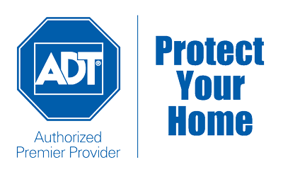

HEMANTH TUMMALA (Z1850110)

PRATHIBHA KOLLI (Z1856874)

CHAITANYA SWAROOP POKURI (Z1853880)

MEGHANA PAMU (Z1857321)

“ADT HOME SECCURITIES”

**TABLE OF CONTENTS**

1. Executive Summary 2 2. Introduction 2

4. Benefits of ADT 3

5. ADT home security system products 4

6. Working of ADT security system 8

7. Challenges faced by ADT 9

8. Conclusion 11

9. Bibliography 12

**EXECUTIVE SUMMARY:**

This case study is about ADT (American District telegraph) home securities which provide different kinds of services regarding securities over 35 countries across the world. ADT networks consists of many services such as home securities, disaster management, home automation, and fire/flood management.

There are many challenges faced by ADT in past years some of them are false alarms and recording video, long-term contact, installation fees and cost and quality of customer service. They have a tough competition from other companies like xfinity, vivint and AT&T. So, they need to overcome the problems to supress the competition given by other companies.

From the investors or shares point of view there is a downfall of ADT shares where the expected share rate is about 14cents for a revenue of $1.09 billion but was out came as loss of 6 cents excluding the extra items. So this made the revenue of ADT a huge loss. So in this case study we will study about the challenges faced by ADT and also explore ways to recover the challenges and flaws of the company is the main topic of our case study.

**INTRODUCTION:**

ADT is one the oldest security companies in the country and has an A+  
rating with the better business bureau. ADT head office was located in Boca Raton, Florida it was established in 1863 by Edward A Calahan. Three years later the president came up with an idea to create a telegraph based alert system in which a group of houses will be having a central station which gets all the alert messages of those houses and get monitored. Finally in 1874, the company was named AMERICAN DISTRICT TELEGRAPH (ADT). ADT began to expand to new areas such as fire alarms and security alarms in the period of 1910 and 1930. In 1964 the company was recorded as the monopoly in the restraint of trade. Almost 80% of the United States has its alarming services. In February 2016 the company was acquired by Apollo global management. Currently ADT has over 8 million customers in USA and Canada. In the year of 2013, ADT held 25%of the market in residential and 13% in the business sector.

ADT observing administrations additionally gives relatively movement notice to both you and crisis work force when your security is ruptured. Following the ADT security establishment process when an alert is set off a flag is sent from your home or business to one of the home security experts at ADT. The ADT observed security proficient at that point cautions you to the convincible security break alongside the police, fire division or crisis work force.

ADT has 140+ years of experience in this sector which provides 24/7 professional monitoring. It also holds theft protection guarantee program. ADT provides home security, home automation, security cameras, fire and safety, monitoring services. In this case study we are mainly concentrating about home securities which include various services such as digital keypad, motion detector, high decibel alarm, flood sensor, glass break sensor, wireless keychain remote and backup battery. ADT does customise alarm system for individual customers according to their needs. Also customers can bring their own equipment or can lease the equipment from ADT like disaster protection and home automation. It also has advanced techniques like video surveillance and live streaming through our mobile app.

**BENEFITS OF ADT:**

Each ADT monitored focus puts a broad system, including frame work experts, accessible if the needs arises to help secure the general population and things you care about most. You can expect ADT security 24 hours every day and 7 days in a week and 365 days in a year. All through the united states, ADT security has full scale system of connected war rooms deliberately situated to effectively offer persistent observing of your protect your home designed security frame work. The best in class innovation coordinated into this flexible, hyper associated activity is just a single of the numerous reasons more individual pick. ADT monitors home security over some other security checking organisation In America. They provide protection against potential hazards that maybe out of your hands including burglary, fire, carbon monoxide, floods and more.

-> Wireless or hardwired equipment

-> Cellular and landline connections

-> Indoor cameras

-> Devices which work at home and outdoors too.

-> Home automation.

-> Monthly rate is low compared to many other companies.

**ADT HOME SECURITY SYSTEM PRODUCTS.**

ADT security system has many different appliances for detection of theft, breakage, fire, paramedics etc, some of the appliances are as named below.

**1.SECURITY KEYPADS:**

ADT security keypads are the CPU of the home security systems, these carry the passcodes, the resident’s information’s and will transmit the information to the ADT personal assistant and also to the police department. They can be personalised according to the customer.

**2.MOTION DETECTORS:**

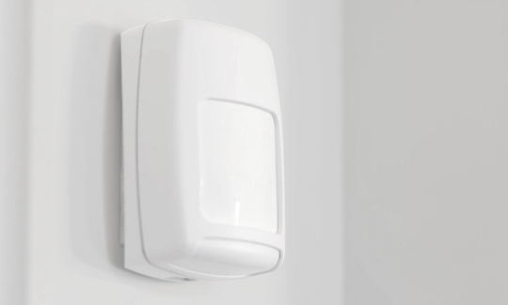Motion detectors are the main weapon of the ADT security system, they cover large area of the home for motion. They trigger the video and the other security systems if any motion is detected, they can be customised for pets by reducing the sensitivity.

**3.DOOR & WINDOW SENSORS:**

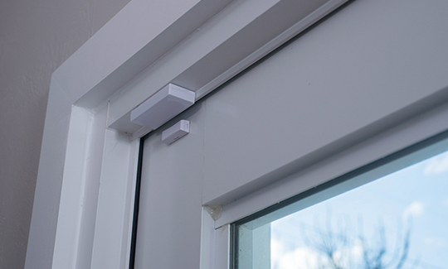These sensors detect if any one enters the home and they will be triggered, when triggered they send an automatic text to the customer. They can be customised as every home is different and have the versatility to fit the house.

**4.GLASS BREAK SENSORS:**

These sensors work by detecting the sound of glass breakage and when they sense it they will immediately notify the monitoring professional and also a text message will be send to the customer.

**5.KEY FOB WITH PANIC BUTTON:**

ADT security systems kay fob is very easy to use, we can easily arm and disarm the security system and if you don’t feel safe you can simply press a panic button which will notify the local emergency services nearby.

**6.SECURITY CAMERAS:**

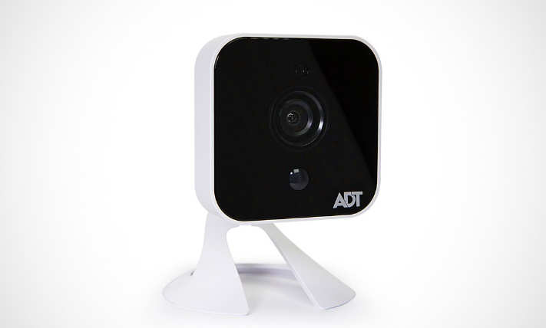Outdoor security cameras are used outside the home and they will detect any motion and will record the video in 720p .They have low light sensing cameras and is weather proof they work in snow, rain and any harsh weather .

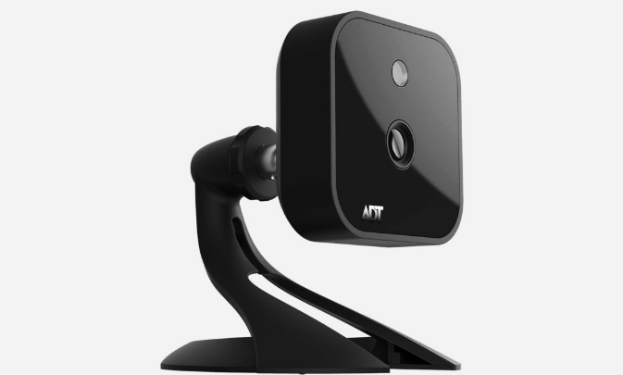Indoor security camera works same as the outdoor security camera has 720 p video recording and has live video surveillance, works in low light and has motion sensors.

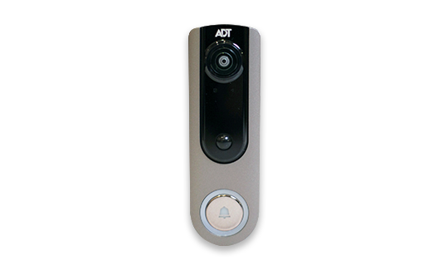 ADT Video doorbell is basically attached to the front door. It has 24/7 video recording which helps is delivering of parcels and also has two way audio system for the resident to interact with the person outside.

**7.FIRE HOME AND LIFE SAFETY PRODUCTS:**

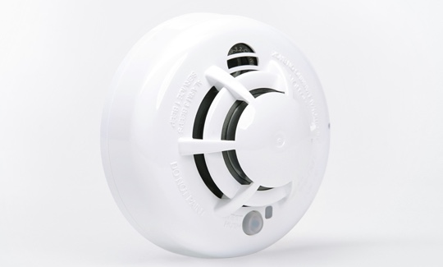ADT some detectors detect any some and also detect heat if any, they have status reminder which helps to test the system by sound and led notification.

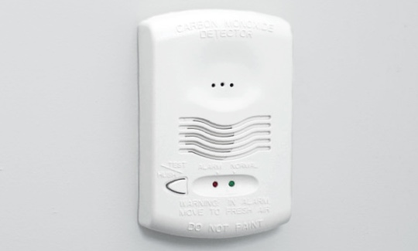ADT carbon monoxide detectors help in detection of colour less odour less harmful gases like CO. They are easily mounted with wireless functioning and is tamper resistant.

ADT flood sensors detect for any water leaks and has wireless mounting flexibility which helps the sensor to be placed near washing machines and also near leakage prone areas .

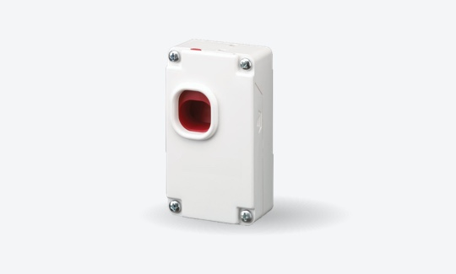ADT security system has a wireless panic button which can be taken in your pockets when this is activated trained professional will be near your home in no time and has separate buttons for us to call for different help.

**8.MONITERING SERVICES:**

In addition to all the security products ADT has 24/7 monitoring services and will contact you and the local emergency services. Before all the security system is installed they inspect the house and consult the customer for the level of security they need.

**WORKING OF AN ADT SECURITY SYSTEM:**

When any of the security sensor is triggered the ADT responds in the following way–

* ADT has different security sensors, each will be triggered in a different way, like the door sensor which will be activated when the door in opened and the glass break sensor which will be activated when it hears a sound of glass break.

* When the system is activated, the system will send a distress signal to the customer via text and it will inform the ADT monitoring personal and in case of high emergency it will directly contact he local emergencies via mobile coverage or landline or via internet.

* When the ADT is notified they will contact the customer just in case of false alarm if the customer didn’t respond they will immediately inform the local emergency services.

* When the dispatcher is notified they will also try to contact he resident to conform the emergency via control pane or through mobile if the customer didn’t contact hey consider it as emergency.

* After the dispatcher conform the emergency they notify all the emergency vehicles nearby including fire and medical services.

* The emergency services should be near the home shortly after they are notified and should provide support to the customer.

This is how ADT security system works when any of the sensor is triggered.

**CHALLENGES FACED BY ADT:**

There are multiple challenges faced by ADT. Some of them are listed below:

1.False alarm:

This is one of the biggest challenges faced by security systems. Due to the false alarm triggering there is a lot of revenue and customer service loss for ADT. The alarm sometimes gets triggered due to unconditional situations of door opening due to pet opening it or due to heavy winds or children opens without adult’s notice can cause some serious problems.

2.ADT in Recording video:

ADT cannot standalone it has to install ADT plus video contract to support video recording. But the problem is that it can record a video up to 30 seconds but cannot store it in the local storage.

3. Long-term contract:

ADT customers are asked by ADT to sign in the lease for at least three years span again if the customer wants to extend the contract, he/she is again asked to sign the lease for three years more which is very long-term contracts when compared to other companies. Due to which most of the customers are not opting ADT which is a big challenge to ADT.

4.Installation Fee:

ADT equipment’s are so sophisticated that they cannot be installed by one individual, so they must take companies help to install them. Many other companies give you a chance to install the equipment by your own which reduces the installation cost which ADT is forcing on its customers. Now this becomes one of the economic problems for the customers.

5.High Cost:

Prices of the equipment of ADT are high and there are very less offers offered by ADT to customers. There is also a possibility of adding services to the plan which a customer is currently in which is a benefit for the customer, but the loop hole is for the additional services the cost of the ADT security systems is increased drastically. Also, one more problem is that a customer cannot get a clear picture of the company offers and plans, so he/she cannot monitor the price of the service.

6.Quality of customer service:

Customer service is main challenge which is faced by many customers which is the first problem to be concerned about. There are lot of customers who reviewed that the customer service is very poor with ADT. ADT customer service was offered in quality manner for some customers and rest are not satisfied. The service is depending on the place where a customer lives which is not acceptable from the customers point of view.

7.Unauthorized dealers:

There were so many customers complaining about the dealers who are selling the ADT products. Many customer reviews that there are No Authorized dealers who are selling the products so many people are getting tricked by this situation falling into misconception that the dealers who are selling the products are the original dealers.

8.Lost Signal:

Losing signal problem is that even when the alarm is triggered there is no alert message or call for cops which is a flaw for ADT system which is concern for many customers because of which the ADT is unable to give its service. There were lots of customers who questioned ADT about this, but ADT was unable to resolve this signal problem or think of any other alternative. Because of this problem there was lot of burglary activities happened even after the house is protected by ADT security system.

**CONCLUSION:**

In our case study about the ADT home securities we first studied about the ADT history, benefits and various services which ADT offer. We also came to know about various products which ADT offers to customers. We also studied about the challenges which are faced by ADT during its progress in the field of home securities. At the end we get to know how a security system works and what are the problems faced by customers and the company.

**BIBILOGRAPHY:**

<https://security.adt.com/d/protectyourhome/packages/>

<https://security.adt.com/d/protectyourhome/health/>

<https://security.adt.com/d/protectyourhome/>

<https://security.adt.com/d/protectyourhome/business/>

<https://www.safehome.org/security-systems/adt/reviews/>

<https://en.wikipedia.org/wiki/ADT_Inc>.

<https://www.safehome.org/security-systems/adt/>

<https://www.adt.com/>

<https://www.protectyourhome.com/adt-security>

https://www.securitychoice.com/resources/adt-history/

<https://www.adt.com/products>